Divine Intervention School
Online Fee Payment
Step-by-Step Guide
- Visit www.onlinesbi.com/prelogin/icollecthome.htm

- Tick the Small Box and Click Proceed
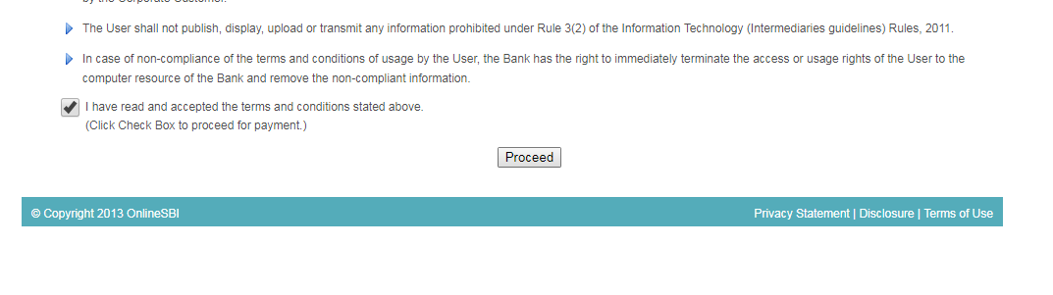
- Select Mizoram and Educational Institutions and Click Go
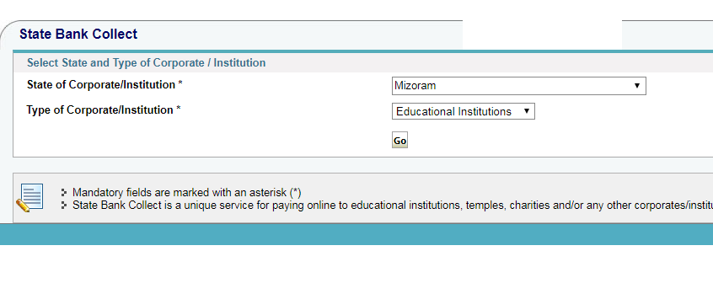
- Select Divine Intervention School and Click Submit

- Select the Type of Fees you are going to pay for the current month. There are seven types of fees. To pay more than one type of fee you will need to repeat from the beginning for each payment.

  - Day Scholar Fees KGI to Class VIII
  - Day Scholar Fees Class IX to Class X
  - Hosteller Fees KGI to Class VIII
  - Hosteller Fees Class IX to Class X
  - Transport Zone 1 School to Chhangurkawn
  - Transport Zone 2 Chhangurkawn to Vaivakawn
  - Transport Zone 3 Vaivakawn to Bawngkawn or Ramrikawn

- Complete the personal details of the student, including their name, class and roll number. Complete your own personal details (Name, DOB and phone number) as required by the bank. Enter the security code. Click Submit.

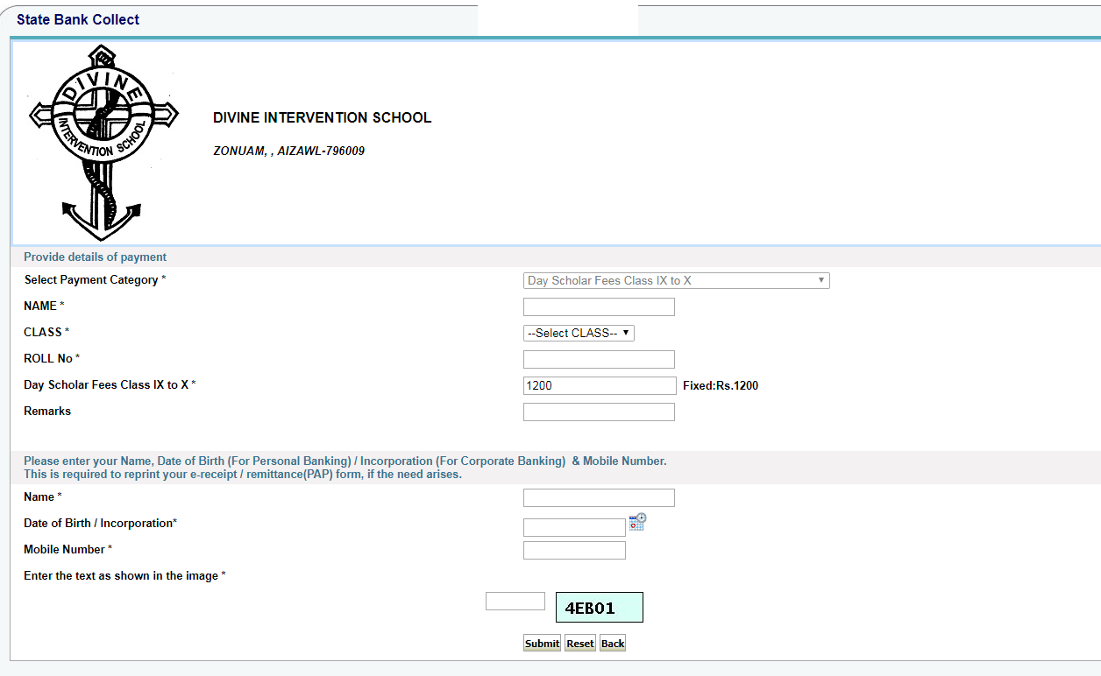

- Confirm the details are correct.
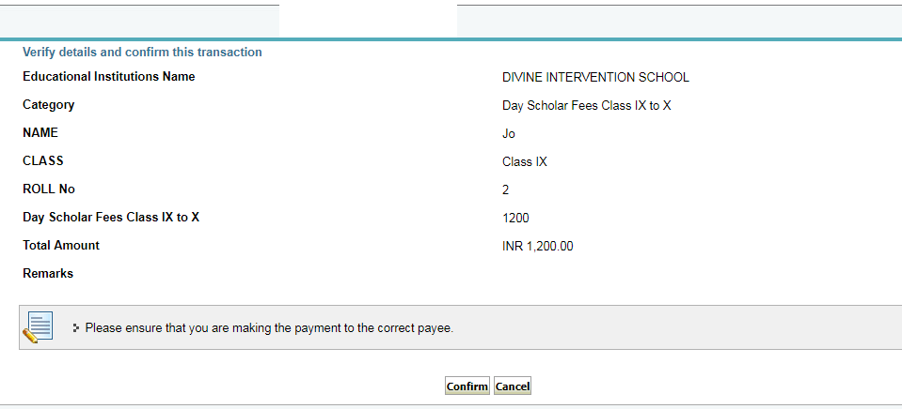
- Select your preferred payment option and proceed using your bank account or banking card details.
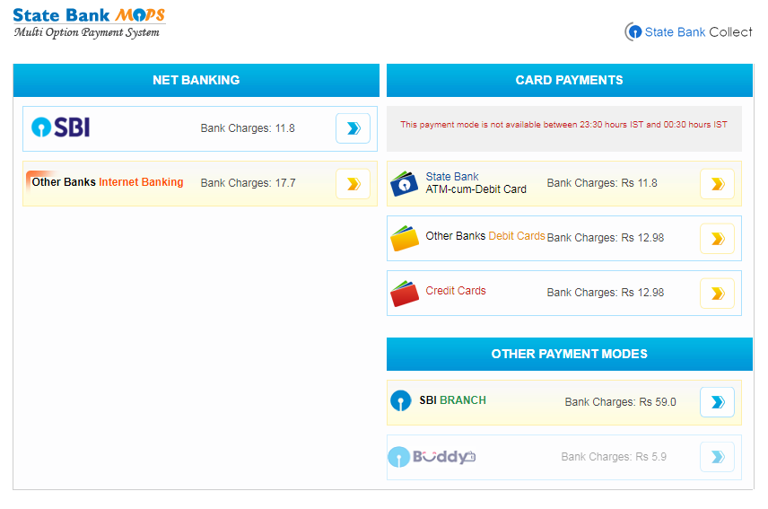
- Confirm payment. You may need your phone with you in order to enter a One Time Password.

Payment Fee: SBI will charge a small service fee at the time of payment.
Late Fees: If your fee payment is late, then late fees will automatically be charged at the time of payment. From the third week of every month, late fees of up to Rs. 150/- will be charged.
If the month has elapsed then it will no longer be possible to pay fees online for that month. You will need to pay at the school office without delay and an additional late fee may be charged.
Card Payment at School: Please note that it is also possible to pay by any credit or debit card at the school office using the card machine.

